For a country that says they value education and basically forces children to use all their time on learning, ironically scored the lowest in reading comprehension in the 2018 PISA.

Memes versus reads: The social media influence on Filipino reading comprehension  
Do Filipinos actually read: The social media influence on Filipino’s reading comprehension.  
Do Filipino netizens actually read: The implications of Memes and News Headlines on Filipino’s reading comprehension.

kung implication mas interesting siya kay ang premise gamay na daan ang reading comprehension sa mga pinoy and this prompts the proliferation of short forms like memes and headlines. So the question is are memes and headlines the solution for low reading comprehension, or do they worsen the problem.  
since memes creation requires high order of thinking.

One area of growing interest is the analysis of memes, short bits of information that are easily reproduced and shared by large audiences.

Pwede ka magmulti-modal approach, meaning you look at communication as a whole, not just from the linguistic angle. Pwede nimo himoong case nga mas makatabang ang short and concise texts plus the use of graphics instead of forcing Filipinos to read mounts of text. Then iconsider ang implication niya sa atong attitudes towards reading. Should everyone read? Or is it better that people are provided with different means to absorb information?

The term ‘meme’ was coined by the evolutionary biologist and philosopher Richard Dawkins (1976) with the intention of explaining the low and lux of culture. Dawkins’ meme represents a unit of cultural transmission or imitation contriving a spontaneous expansion, variation and replication of human ideas (2006:192–195). Meaning tunes, ideas, catch-phrases, clothes fashions, ways of making pots or building archers are all examples of memes (Dawkins, 2006:192).

Include one paragraph each for the research problem (10 pts), the related literature about this problem (25) pts), the deficiencies in the literature (10 pts), and the audiences who will potentially find the study of interest (10 pts). (List down all your references at the end)

Among 79 participating countries and economies, the Philippines scored the lowest in reading comprehension in the 2018 Programme for International Student Assessment (PISA). This is alarming as “Reading proficiency is essential for a wide variety of human activities - from following instructions in a manual; to finding out the who, what, when, where, and why of an event; to communicating with others for a specific purpose or transaction,” the summary of the PISA 2018 results reads. To comprehend a text, one must read. Memes and news headlines have become the main determinant of this study as 1) in our modern media environment characterized by participatory media culture, memes have become a tool for citizens seeking to participate actively and discursively in a digital public sphere, and 2) in the height of the political season in the Philippines, headlines of newspaper articles on the internet have also become the subject of Filipino’s topic in a discourse.

This study aims to identify whether memes and news headlines have an effect on Filipino netizens’ reading comprehension.

Research Question: Is the proliferation of memes equate to comprehension? Or do netizens just engage with memes without comprehending?

Grabarczyk, P. (2019). Can memes explain the birth of comprehension? AVANT Journal, Vol. X, No. 3

Grabarczyk (2019), on his polemic against Dennett’s (2017) From Bacteria to Bach and Back argued that the theory memes does not deliver with Dennett’s wish with bridging the gap between competence and comprehension. Dennett reintroduces the theory of memes which gets possibly the most thorough explanation since its introduction in (Dawkins, 1989), by using meme transmission as an analogy for gene transmission. Genes played the role of unobserved properties responsible for the regularity of the transmission of observable properties. If we follow this analogy and look at memes, we could also start with some observable phenomena – words being repeated, ideas being shared, sayings being carried over through generations, tunes being popularized and so on. But memes are not supposed to be the extra posits responsible for the transmission. They are not the unobserved fillers of our epistemic gaps. However, Grabarczyk

Hartman et. al., (2021) proposes that artistic response strategies can facilitate meaning-making at the evocative dimension of response and lead to deeper responses in the cognitive and reflective dimensions. As English Language Arts teachers, they have found that students often make meaning of texts by connecting them to other texts from the popular culture they know and value. For instance, their students frequently referred to current memes in order to draw parallels with what we were studying. The researchers created the Perspective Meme activity as a way for students to explore character development through artistic response. In general, memes can be useful tools in the classroom when used strategically. They can help students organize complex information about literature, writing, or other aspects of language arts in a relatively low-risk and familiar way. A meme’s simplicity in form can make it more accessible for students than a traditional essay or composition, which often require students to consider elements such as organization, mechanics, grammar, flow, and style. Furthermore, because most students are familiar with memes, the perspective meme strategy can help activate background knowledge by allowing students to apply a familiar means of interacting with information to a text.

Procházka (2014) examines the recently emerged multimodal artefacts commonly known as

Internet memes in the light of the new literacies that are rapidly emerging in the digital age. The Internet has introduced new online reading comprehension skills that redefine the traditional concept of literacy. In other words, traditional print environments require a relatively small set of reading comprehension strategies and skills, while online environments require not only traditional skills of reading comprehension, but also new types of knowledge to effectively locate, critically evaluate, synthetize and communicate information on the Internet.

Purpose statements indicates why you want to do the study and what you intend to accomplish. Sets the objectives, the intent, or the major idea of a proposal or a study. This idea builds on a need (the problem) and is refined to specific questions (research questions)  
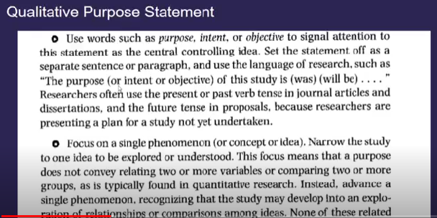

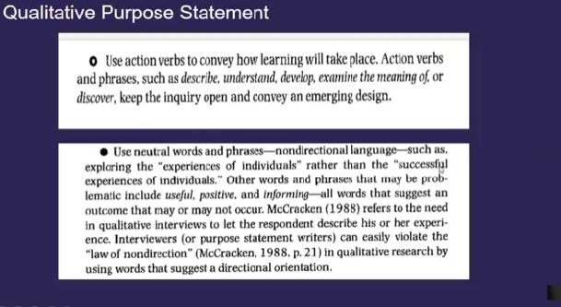

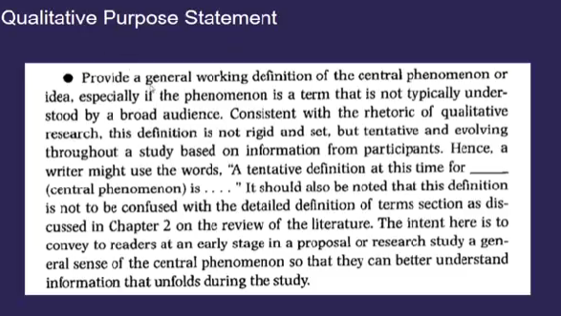

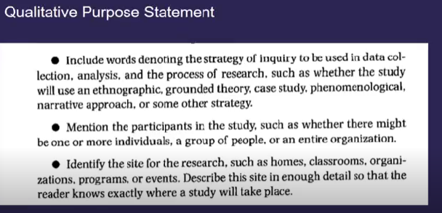

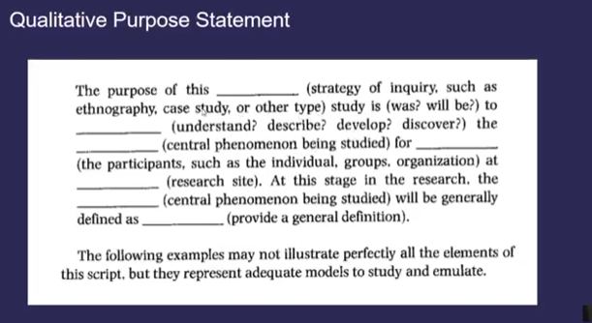

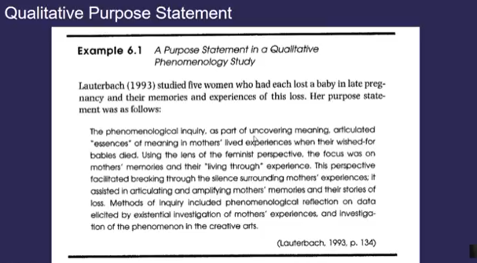

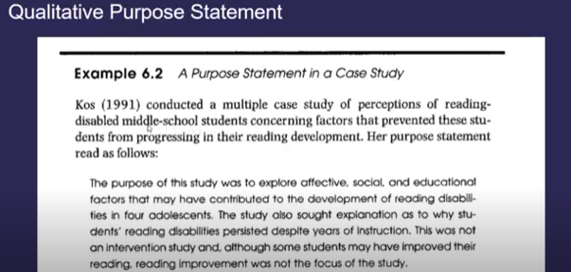

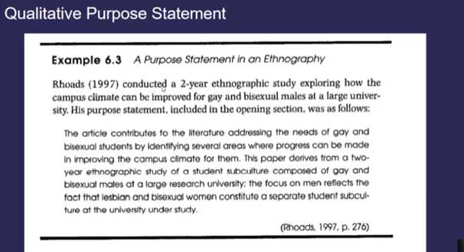

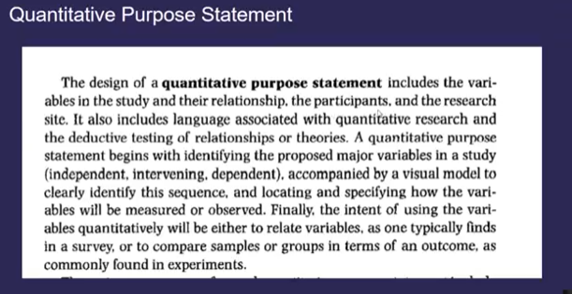

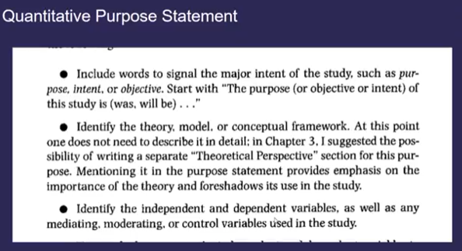

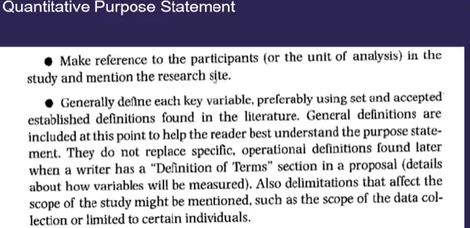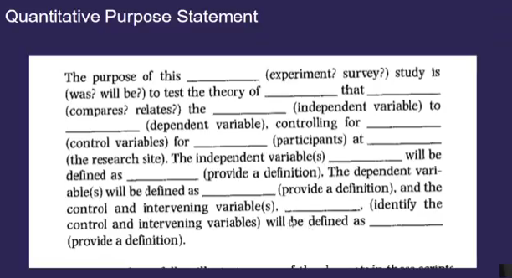

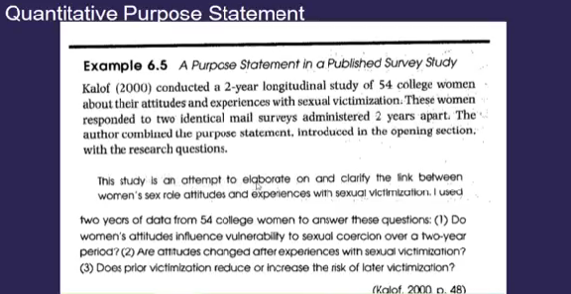

(sex role attitudes experiences = independent variable(cause), sexual victimization = dependent variable(effect))

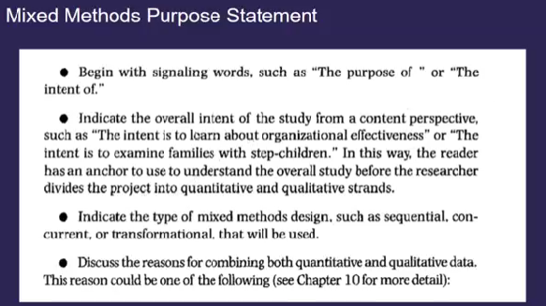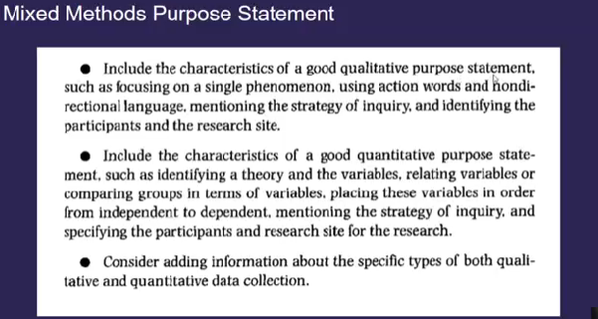

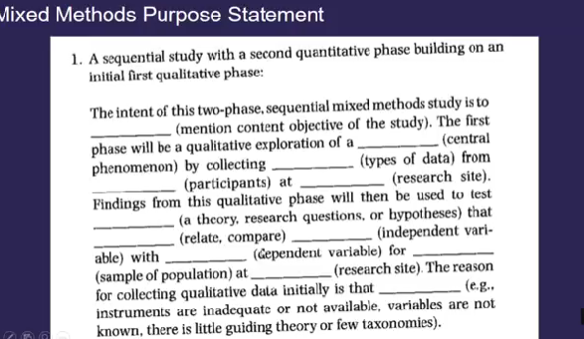

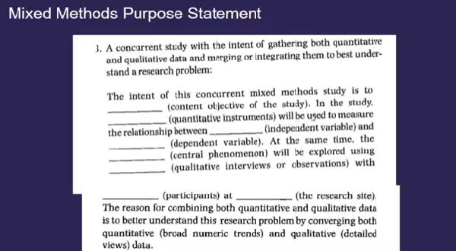

(concurrent = triangulate)

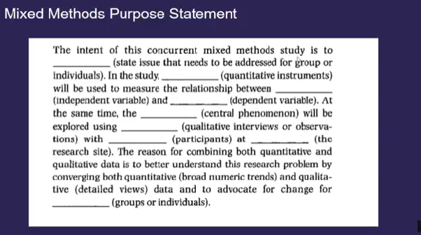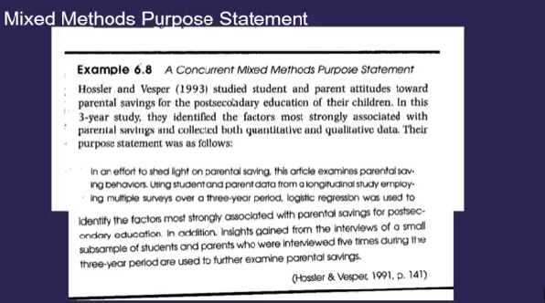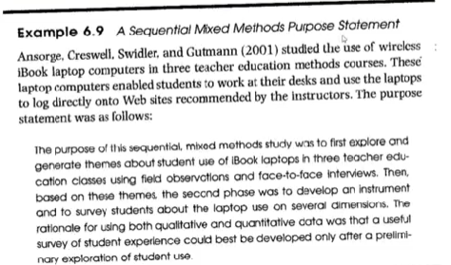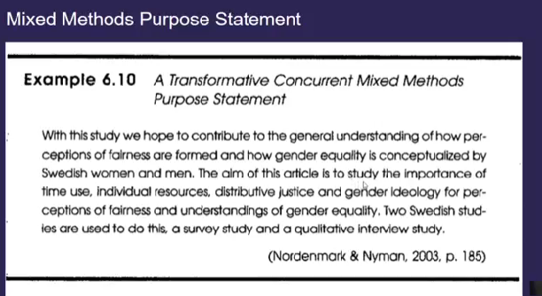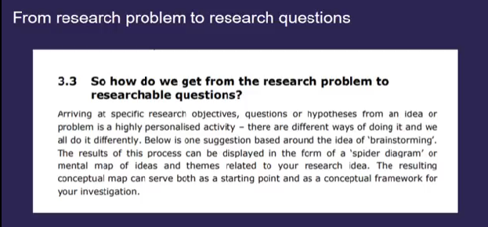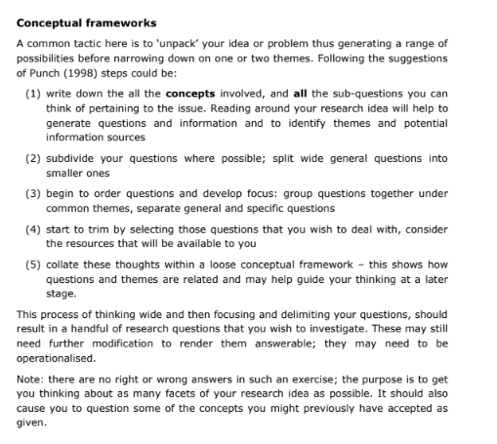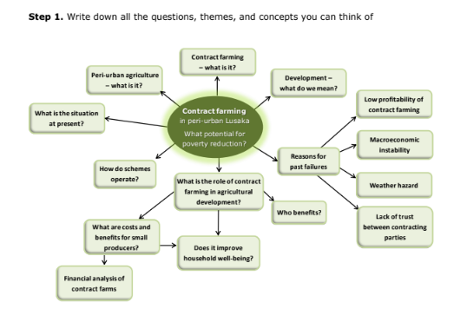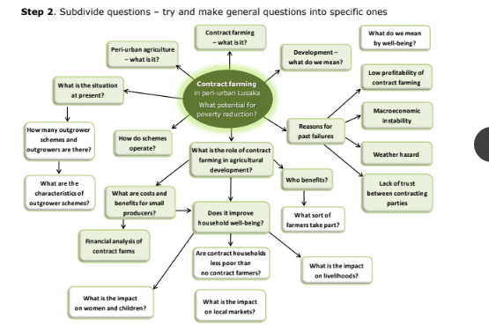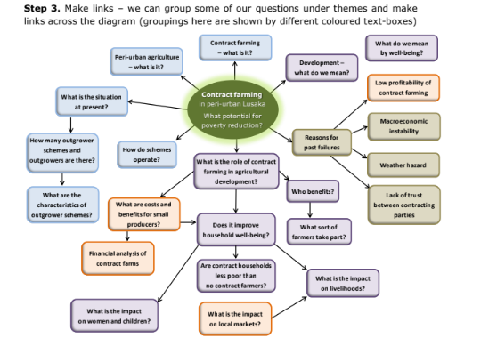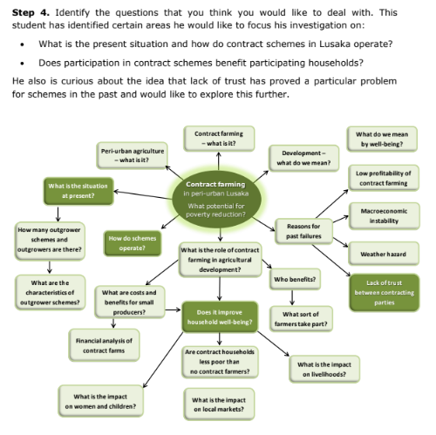

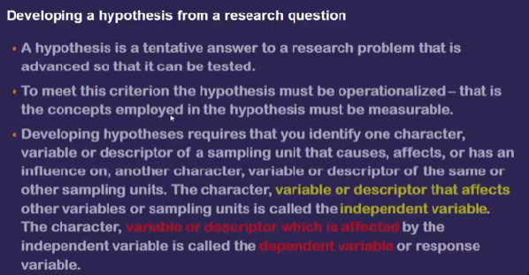

(usually for quantitative research it needs hypothesis)

